
COLLEGE PAYROLL ACCOUNTING
Contestant Number:
Time:
Rank:
(130)

NATIONAL – 2020

Multiple Choice & Short Answer Section:

Multiple Choice (15 @ 2 points each) (30 points)

Short Answers Questions (40 @ 2 points each) (80 points)

Production Portion:

Problem 1: Percentage Method Withholding (20 points)
Problem 2: Tax Deposit (22 points)
Problem 3: Form W-3 (44 points)
Problem 4: Form 941 (38 points)

TOTAL POINTS (234 points)

Failure to adhere to any of the following rules will result in disqualification:
- Contestant must hand in this test booklet and all printouts. Failure to do so will result in disqualification.
- No equipment, supplies, or materials other than those specified for this event are allowed in the testing area. No previous BPA tests and/or sample tests or facsimile (handwritten, photocopied, or keyed) are allowed in the testing area.
- Electronic devices will be monitored according to ACT standards.

No more than ten (10) minutes orientation
No more than ninety (90) minutes testing time
No more than ten (10) minutes wrap-up

General Instructions

You have been hired as a Financial Assistant and will be keeping the accounting records for Professional Business Associates, located at 5454 Cleveland Avenue, Columbus, Ohio 43231. Professional Business Associates provides accounting and other financial services for clients. You will complete jobs for Professional Business Associates’ own accounting records, as well as for clients.

You will have 90 minutes to complete your work. The test is divided into two parts. The multiple choice and short answer questions should be completed first, and then the accounting problems may be completed in any order.

Your name and/or school name should NOT appear on any work you submit for grading. Write your contestant number in the provided space. Staple all pages in order before you turn in your test.

Assumptions to make when taking this assessment:

- Calculate all calculations to four (4) decimals, then round to the nearest cent.
- 2019 Payroll Tax Rules Apply
- Social Security (OASDI): 6.2% on the first $132,900
- Medicare (HI): 1.45%
- FUTA: .6% on first $7,000 of employee wages
- SUTA: Information is in each question

Multiple Choice:

- The end of the year federal payroll reporting forms are
  - 1099 and 1096
  - W-2, W-3, 941 and 940
  - W-4 and I-9
  - Both a and b

- An employer who files a Form 944 has annual OASDI, HI and federal tax withholding liability that is
  - Less than $100,000
  - Less than $10,000
  - More than $1,000
  - Less than $1,000

- A 16 year old, full time high school student is hired by the Freedom Bell Company. FBC is eligible to pay her _______ for the first 90 days.
  - $8.25 per hour
  - $2.13 per hour
  - $6.16 per hour
  - $4.25 per hour

- Which of the following are NOT a Section 125 plan?
  - Employee Stock Option Plan (ESOP)
  - Health Savings Account (HSA)
  - Dependent Care Assistance
  - Health Care Benefits

- Which statement about FMLA is false?
  - It can be taken for a family illness
  - An employee can take up to 12 weeks of unpaid leave
  - It protects the employee from losing their job
  - The employer cannot pay the employee during leave

- Which of the following is an example of a Defined Benefit Plan?
  - A Pension Plan
  - A 401(K)
  - An IRA
  - An ESOP

- Uncle Sam earns gross wages of $1,050 per week. What week will Sam be over the FUTA rate (no portion of the paycheck will be taxed)?
  - Sixth
  - Seventh
  - Eighth
  - Ninth

For the next six questions, use the following information. The Monument Tour Company pays all employees weekly. They have 3 employees with the following information.
Name | W-4 Information | Weekly Wage
Jeb | Single – 2 | $1,775
George | Married – 3 | $2,925
Prescott | Single – 0 | $2,250

- Which employee(s) will reach the OASDI cap?
  - Jeb
  - George
  - Prescott
  - All will go over

- Which employee(s) will reach the HI cap?
  - Jeb
  - George
  - Prescott
  - None will go over

- How much is the employer’s FICA tax expense for the first payroll of the year?
  - $430.90
  - $100.78
  - $531.68
  - Unable to calculate

- Which employee(s) will reach the FUTA cap?
  - Jeb
  - George
  - Prescott
  - All will go over

- What is the maximum amount of FUTA, provided all payments are made timely?
  - $126.00
  - $162.00
  - $84.00
  - Unable to calculate

- How much is the employer’s FICA tax expense for the 50th payroll of the year?
- $531.68
- $350.33
- $430.90
- $100.78

- If Janine Carter, a married employee, refuses to complete the W-4 form, the employer must
  - Fill out the W-4 form for Mrs. Carter
  - Fire Mrs. Carter
  - Withhold taxes at the Single rate with 0 allowances
  - Withhold taxes at the Married rate with 0 allowances

- An employer report that show wage amounts going into internally classified categories is
  - An Employer’s 941 Quarterly Report
  - A Gross Earnings Report
  - An Employees Earning Report
  - A Labor Distribution Report

Short Answer Questions: (80 points)

- The following data was collected from The Liberty Manufacturing payroll records for the current year payroll of April 19, 2019. Liberty’s SUTA rate is 2.63% (Assuming the FUTA and SUTA taxable limits are both on the first $7,000 of wages earned)
Employee | Cumulative Earnings Prior Pay Periods | Current Pay Period Earnings | FUTA/SUTA Taxable Amount | FUTA Tax Liab | SUTA Tax Liab | FICA Tax Liab
Reagan | 7,023.00 | 985.00
Carter | 6,511.25 | 1,925.25
Kennedy | 1,580.00 | 366.00
Clinton | 2,989.00 | 677.00
Truman | 9,940.63 | 1,358.47
Ford | 4,418.00 | 2,125.00
Wilson | 6,502.99 | 895.00
Totals

- Calculate the gross wages indicated in the table:
Employee | Annual Salary | Weekly | Bi-Weekly | Semi-Monthly | Monthly
Abigail |  |  |  |  | $2,215
Dolley |  |  |  |  | $3,595
Elizabeth |  |  |  |  | $4,500
Louisa |  |  |  |  | $4,294
Emily |  |  |  |  | $3,376

- Christie Coolidge is an office worker who earns a salary of $96,578 per year and is paid on a weekly basis. She works the following hours:
Monday | Tuesday | Wednesday | Thursday | Friday
8 hours | 9 hours | 12 hours | 6 hours | 4 hours

How much will Ms. Coolidge’s gross pay be for the week? $______________________

- Walter McKinley works under a piece-rate work agreement. Walter is paid weekly for the following pieces during a particular week. Calculate Walter’s regular pay. He is paid $3.77 per piece and is calculated & rounded on a daily basis.

Monday (8 hours) 51 pieces
Tuesday (8 hours) 48 pieces
Wednesday (7 hours) 42 pieces
Thursday (8 hours) 60 pieces
Friday (6 hours) 40 pieces

Regular Earnings $
Regular Minimum Hourly Rate $
Total Earnings $

- Jean Kennedy works at an office and earns the state minimum wage of $12.58 per hour. If she works 44 hours in one week, what amount of OASDI will be withheld in that week?

$______________

- Wilma Harding is a tipped employee who engages in an occupation where she earns more than $30 in tips per month. During one week, she earns $202.50 from her employer after working 40 hours. What was her hourly wage from tips and her employer?

Hourly wage from tips $__________________

Hourly wage employer pays her $__________________

Problems:

- (20 points, 5 points each) Calculate the Federal Withholding using the percentage method assuming the following scenarios. Weekly withholding allowance = $80.80 for each allowance.
Employee | Weekly Salary | Marital Status | Allowances | FIT Withholding
Rutherford | $585 | Single | 1
Ulysses | $735 | Married | 2
Chester | $1,475 | Single | 0
Benjamin | $2,570 | Married | 3
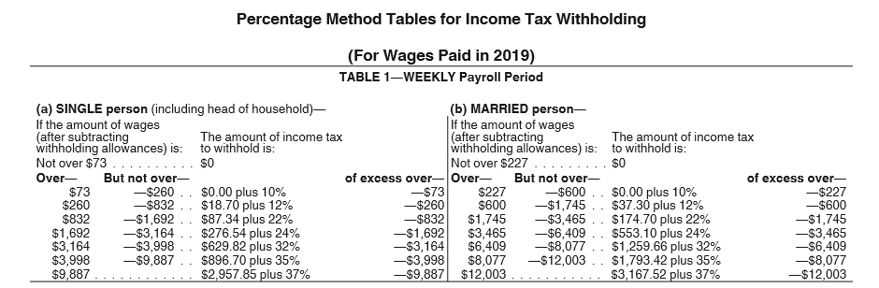

- (22 points, 2 points each) Use the information from Problem 1 to complete the
Form 8109-B below for the first payroll of the year. USA Tours Company Federal ID number is 12-3456789. USA Tours address is 555 White House Lane, Richmond, VA 98765 and phone number is (999)123-4567. Include FICA taxes.

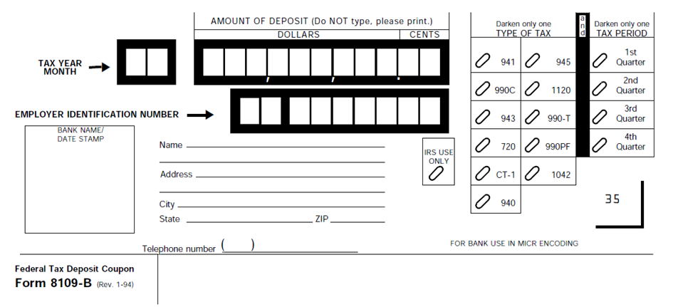

- W-3 (44 points 2 points each) USA Tours Company Federal & State ID number is 12-3456789. USA Tours address is 555 White House Lane, Richmond, VA 98765 and phone number is (999)123-4567. You are the employer’s contact. Your email is payroll@usatours.com and the fax is (999)123-4568. Use this information to complete the W-3 form below.
Employee | Annual Salary | FIT Withholding | State Withholding
Rutherford | $30,420 | $4,222 | $1,308
Ulysses | $38,220 | $3,751 | $1,644
Chester | $76,700 | $5,498 | $3,298
Benjamin | $133,640 | $10,264 | $5,747

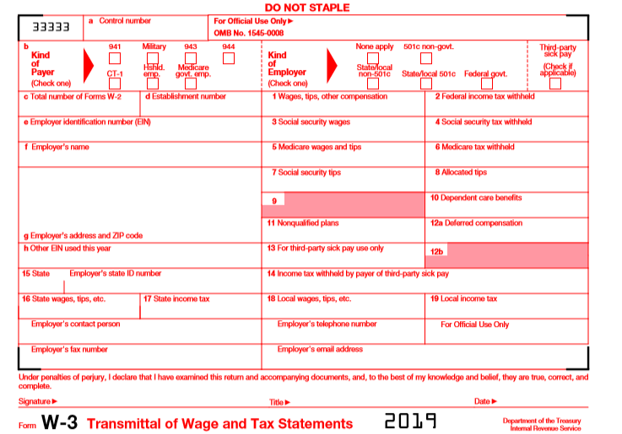

- (38 points, 2 points each) Use the following information to complete the Form 941 on the next two pages. USA Tours Company Federal & State ID number is 12-3456789. USA Tours address is 555 White House Lane, Richmond, VA 98765 and phone number is (999)123-4567. The payroll information from the 2nd quarter follows:
- 4 employees
- Monthly Total wages $21,460
- Monthly Federal Income Tax Withholding $1,977
- Monthly Deposits $5,260.38

